**Revolutionizing the Education Industry using Augmented and Virtual Reality**

Smita Jangale1, Vaibhav Goyal2, Rohini Yedelli3, and Radhika Raghuwanshi4

**Abstract** From ancient times, books have been a source of learning and teaching young minds about everything that happens around us. While books have been a great inspiration, they couldn't effectively provide the practical knowledge about the real world where the information which is learned in the books is actually implemented. For that, one had to go outside in the world and experience and learn by themselves. With new discoveries happening all around the globe every day, there is so much to learn and so little time to see and experience it in the real world. That’s where Augmented and Virtual Reality are giving a boost to the learning experience and inventing new ways for more effective and efficient learning.

This paper highlights new and creative ways in which Augmented and Virtual Reality can be used to help young minds to learn effectively and efficiently. This paper also surveys various applications of virtual reality and augmented reality in the field of education and tourism.

***Keywords:* Target, Recognition based AR, Virtual Environment, Rendering data, Tourism, Engineering Drawing, Visualization, Marker based Augmented Reality, Markerless based Augmented Reality.**

# INTRODUCTION[1]

virtual Reality (VR) is a computer simulated reality which replicates the real world and simulates the users physical presence in that computer generated world while in Augmented Reality (AR) the user is present in the physical real world and the computer generated objects are superimposed upon or composited with the real world.

The traditional “chalk and talk” teaching method and the use of static textbooks fail to engage students and lead to inferior learning outcomes[2]. The traditional techniques used repetition and memorization of information to educate students. It meant that they were not developing their critical thinking, problem solving and decision-making skills. The use of modern technologies encourages students to be more productive. The integration of technology also provides a means to enhance student learning and engagement in lectures. Therefore, recent studies have aimed to better understand the applications adapted during lectures from the perspective of students, including multimedia, computer-based simulations, animations and statistical software. Research by Geer and Sweeney (2012) showed that the use of a variety of media applications to explain concepts increased the understanding and supported greater collaboration between students [2].

Augmented reality and Virtual Reality is a new technology that has emerged with potential for application in education. Virtual Reality though initially had its roots in the game industry is now growing in education and tourism. While a lot of research has been conducted on AR, few studies have been conducted in the education field. The number of studies on AR and VR is growing due to the effectiveness of this technology in recent years. In particular, AR provides an efficient way to represent a model that needs visualization. AR also supports the seamless interaction between the real and virtual environments and allows a tangible interface metaphor to be used for object manipulation. Virtual reality as a tool that has the ability to enhance education with immersive and interactive experiences.

When students have difficulties in understanding the abstract concept or to visualize the concept, it leads to misconceptions. Visualization of these abstract concepts have great potential for facilitating understanding and preventing misconceptions. Kozhevnikov and Thornton (2007) found that is possible to improve students’ visualization skills with the help of visualization technologies such as virtual objects, animation, virtual environments and simulation. Furthermore, the additional context of visualizing makes it easier for students to commit the information to memory compared to rote memorization. AR and VR allow detailed visualization and object animation and displays objects and concepts in different ways and at different viewing angles which helps the students to better understand the subjects[2].

AR is the modern technology that can be used to improve the learning and visualization of three-dimensional shapes instead of the traditional method in which teachers use wooden objects or paper models [2]. AR can also be used to bring static objects to live and make the learning process more interactive.

One of the greatest uses for virtual reality in the field of history is to take virtual visits to historical places. It can also be used in the field of tourism the users use Google Cardboard and their smartphones to journey to their virtual destination and explore. The application may also contain information to explain and give details of that historical place [3].

# Virtual Reality

## *Introduction*

Virtual Reality is a technology that allows the user to navigate and interact with the virtual world in real time. The virtual environment is three dimensional environment where user can navigate and view in 360 degrees. The virtual environment is an illusion that can be seen using head mounted devices.

## *Components*

The system consists of three important stages that are, software, VR engine and end users. The software stage is responsible for geometric and kinetic modelling of the virtual world. The VR engine acts as an interface between the user and the software through input output devices. Input is provided by the user with the help of gyroscope and magnetometer (compass) inside the mobile handset to register the movement of the neodymium magnet as a click option on the mobile screen. After any action performed, respective output is mapped onto the virtual world and showcased to the end user.

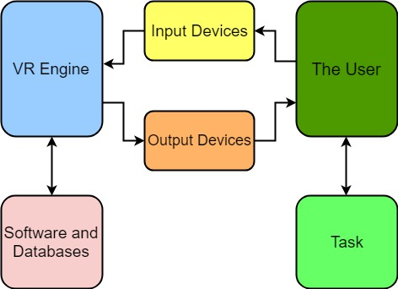

Fig 1: Components of VR System.

# Augmented Reality

## *Introduction*

Augmented Reality (AR) is a technology that aims to enhance the real environment by projecting virtual objects/models on top of it. AR system has the following characteristics:

1) Combine real and virtual;

2) Interactive in real time;

3) Registered in 3D [1].

AR experience can be provided using mobile phones and computers. AR is different than VR in the aspect that AR extends reality rather than replacing it. Augmented Reality enhances user’s perception, imagination and interaction with the real world. Thus, interactive learning is helping augmented reality in making its root in education industry.

## *Components*

Augmented reality systems are built upon on three major building blocks [1]:

1. Tracking and Registration

Tracking and Registration are needed to know the user’s exact location in comparison to his surroundings and also is used for tracking the exact eye and head movements of the user. This is the most complex part of the Augmented Reality technology as three major functions such as tracking the overall location, movement of the user’s head and eye and adjusting the graphics to be displayed are done with the utmost precautions.

2. Display technology

Types of displays are used in AR technology are:

● Head Mounted Displays [HMD]

Head Mounted Display keeps both the images of the real physical world and the virtual graphical world over the user’s world view.

● Handheld Displays

Such displays are small in size and will easily fit in one hand. These devices use video transparent techniques to relate the virtual world to the real world. Since they are easily portable and due to the bulk use of camera phones, they are used widely.

3. Real time rendering

Real time rendering means as the orientation of the target object changes in the real world, the orientation of the projected 3d object should also change simultaneously without any flickering.

*C. Types of Augmented Reality System*

Augmented Reality Systems are of four types:

1. Projection Based AR Systems[9]

Projection-based AR is described as a video projection technique, which can extend and reinforce visual data by throwing images on the surface of 3D objects or space; this belongs to Spatial Augmented Reality in a broad sense.

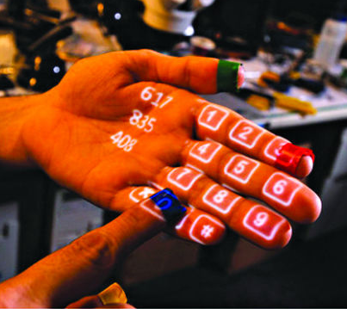

Fig 2: Dial pad projected on the hand of a user

Using projection-based AR, it is easy to implement graphical representation that ordinary lighting techniques cannot express. Unlike general lighting technique, the technique can project high-definition image or video, and change the object shape visually with the flow of time. Therefore, it can show visual images dynamically.

2. Recognition Based AR System

Recognition-based AR is classified as Marker-based AR or Markerless AR. Marker-based tracking system detects target objects(3D or 2D) on the live camera capture and overlays rich media stored in its database onto the target object[10]. The overlaid media gets enlarged when the target object is moved closed to live camera capture and is zoomed out when target object is moved away from camera capture.

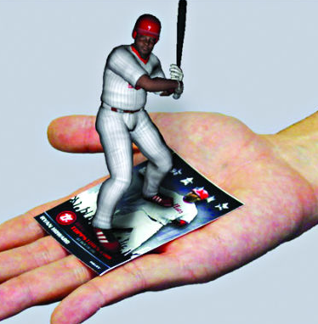

Fig 3: Object is overlaid on target object

Markerless AR systems are not dependent on any target objects and simply project the objects onto the real world. These objects can be idle or in motion in the real world. In this technique the object is at a fixed distance from the live camera capture and if you try to move closer to the object with respect to real world axis, the object moves farther away keeping a fixed distance from the live camera capture.

3. Location Based AR System

Location based AR System uses Global Positioning System(GPS) sensor of the phone to detect the user geolocation and overlay the 3d models in the real world. In this technique, every object is assigned a latitude and longitude coordinates of the real world which is stored in the application itself. When the user at that exact position uses live camera, the 3d model is projected at those coordinates. Location-based AR systems are mainly used for tourism and in travel guidance system.

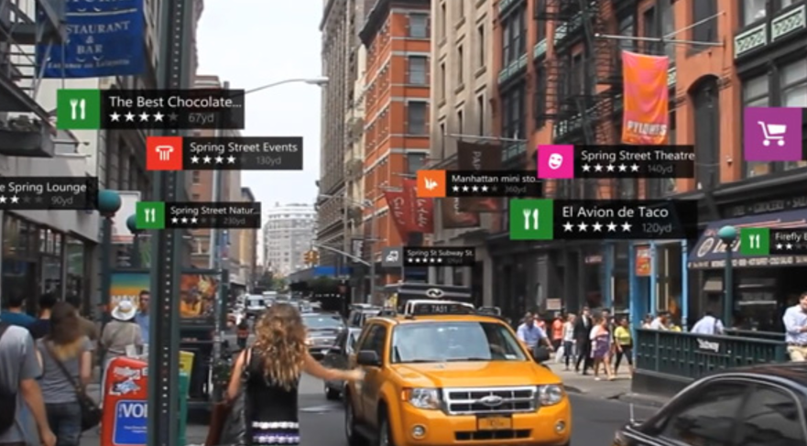

Fig 4 : Restaurant Recommendation System in real time environment

4. Superimposition based AR System[11]

Superimposition based AR System is superimposition of synthetic objects on real world objects within environment.

This technique assumes that the real objects are not moving but dynamic superimposition is also possible by anatomical motion tracking.Various applications where this AR System is used are surgical assistance for medical purposes, Engineering applications and Military simulations.

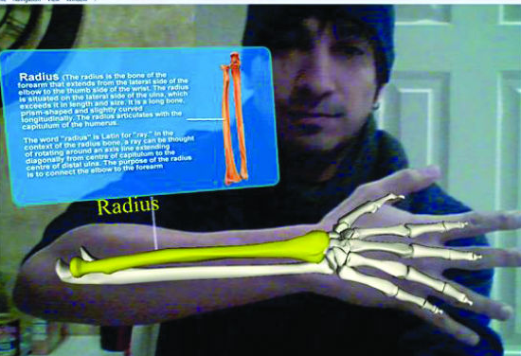

Fig 5 : Skeletal Architecture of hand superimposed on real hand

*C. Detailed Working of Marker Based AR System*

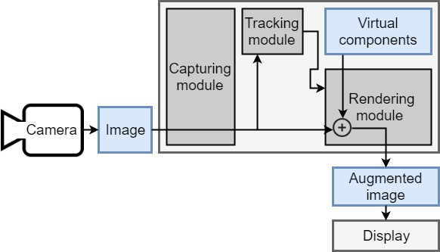

Fig 6: Flowchart for a simple Marker Based AR System.

The modules of the flowchart are explained below:

1. Capturing module

The device captures the image i.e. whatever is viewed through the camera, deduces the location and orientation of the camera.

2. Tracking module

The tracking module is the most important process in the marker based AR; it calculates the relative pose of the camera in real time. The term pose means the six degrees of freedom (DOF) position, i.e. the 3D location and 3D orientation of an object. The tracking module recognizes the AR marker/target and enables the system to add virtual objects. The tracking module enables the system to superimpose virtual components onto the target.

3. Rendering module

The rendering module superimposes the virtual object on top of the camera image. It combines the real environment and the virtual objects and renders the augmented image on the display screen.

# Recent trends in education industry

In mid-20th century, the world realized that for the progress of the nation it was necessary to reform the education system and move ahead from classroom teaching which used blackboards and whiteboard. But these techniques of teaching were not sufficient, as sea of information was discovered and invented daily all around the world. It was nearly impossible for young minds to access it unless it was available in the books and even then books were insufficient to cover all the information. In 1980s digital age arrived and computers were made available to the general public. Computers were used to store information in digital form which was available to the people as and when required. After this in the late 20th century, the internet became popular as information was available with just a click without storing it on the computer. In early 21st century, schools/colleges started becoming smart classes. Smart classes are conducted by a teacher using a viewing screen/computer that is attached to the projector. Students learn the audio-visual information that is projected on the screen. Digital learning help students understand things better.Students commonly find Science subjects to be abstract, requiring a depth of understanding and visualization skills (Gilbert, 2004)[2]. VR and AR has been adopted by the military where it is used for training purposes. This is useful for training soldiers for war situations where they have to learn how to react in an appropriate manner[2].

# Implemented System

In our proposed system we have explored new ways in which augmented and virtual reality could be used to provide interactive and efficient learning.

1. Learning about historical sites

People love to visit different places with historical values but it involves spending a lot of money and time as well. Even financial conditions can be an obstacle in experiencing human made or natural wonders of the world.

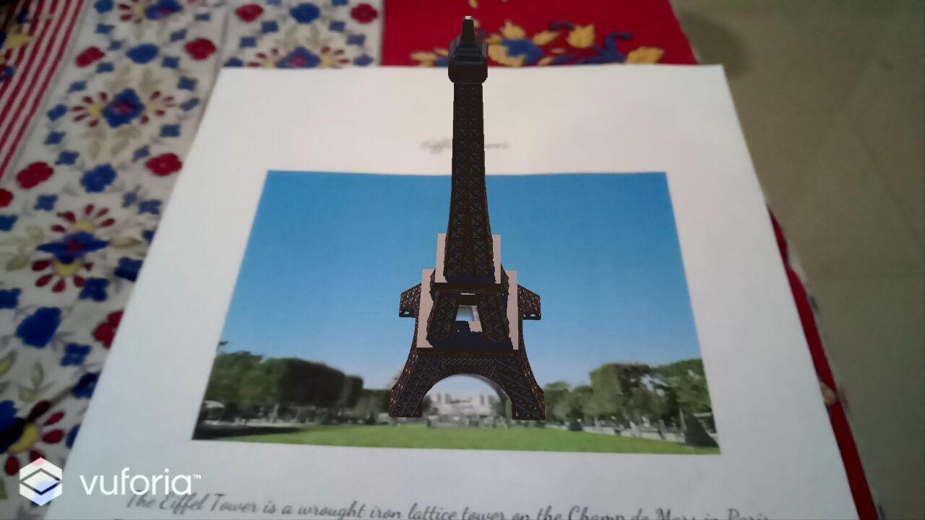

Fig 7: Model of the Eiffel Tower is projected on the Image Target

AR in tourism can save a lot of time and is available free of cost. By using AR, one can enjoy the scenic view of historical sites in its true form while sitting at home. Also, an audio could be played along with visual effects which will give info about the historical importance of that place.

1. Story Telling

Kids are always eager to listen to stories. But it would be more fascinating and indulging for them if their favourite characters would come alive and act in front of them. AR Storytelling brings alive characters which will tell their own stories in interactive manner. Through ‘AR Storytelling’, imagination skills of kids improves which might help them in future.

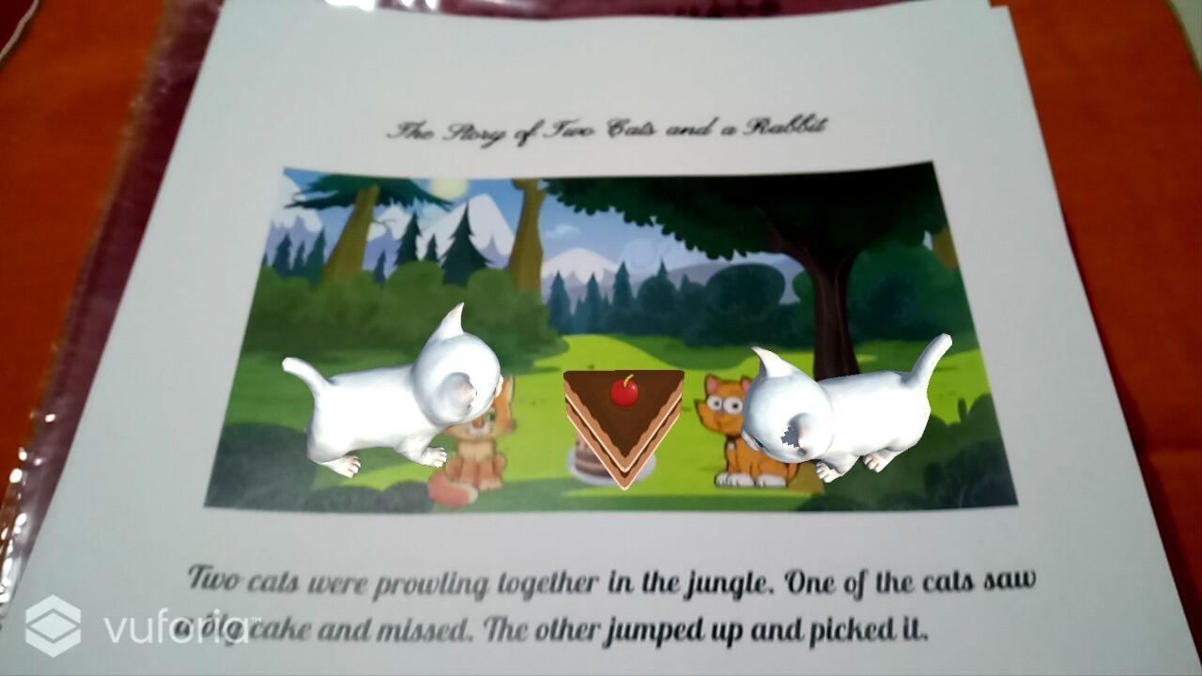

Fig 8: Animated characters on the Target Image

1. Engineering Drawing Models for students

A compulsory subject for all engineering students, Engineering Drawing turns out to be a nightmare because of its complex 3d models. Students are not able to imagine the 3d models just by looking at the 2d drawing of the 3d model. AR in Engineering Drawing will help the students to imagine the models in real world 3d space. The AR models available will be for specific problems, but it will help the students to get an idea about other similar problems.

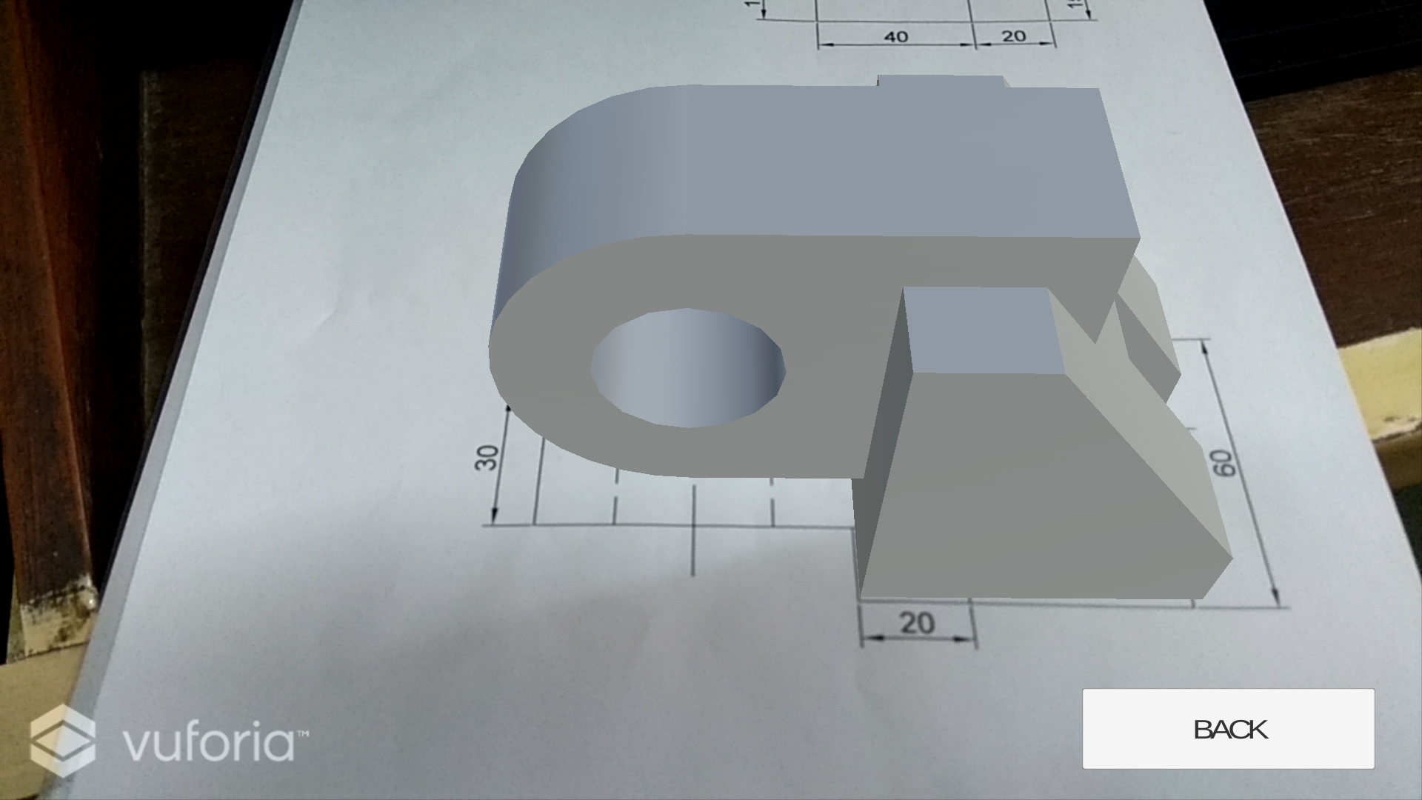

Fig 9 : Orthogonal Projection of 2D structures into Isometric 3D model

1. Painted Cube Problem

Painted Cube is a classic logical problem in which we take a cube and paint it on all sides and cut it into pieces. For e.g. 3*3*3 sided cube is cut into 27 small pieces. Then we are asked to calculate the number of cubes with three sides, two sides, one side and no side painted cubes.

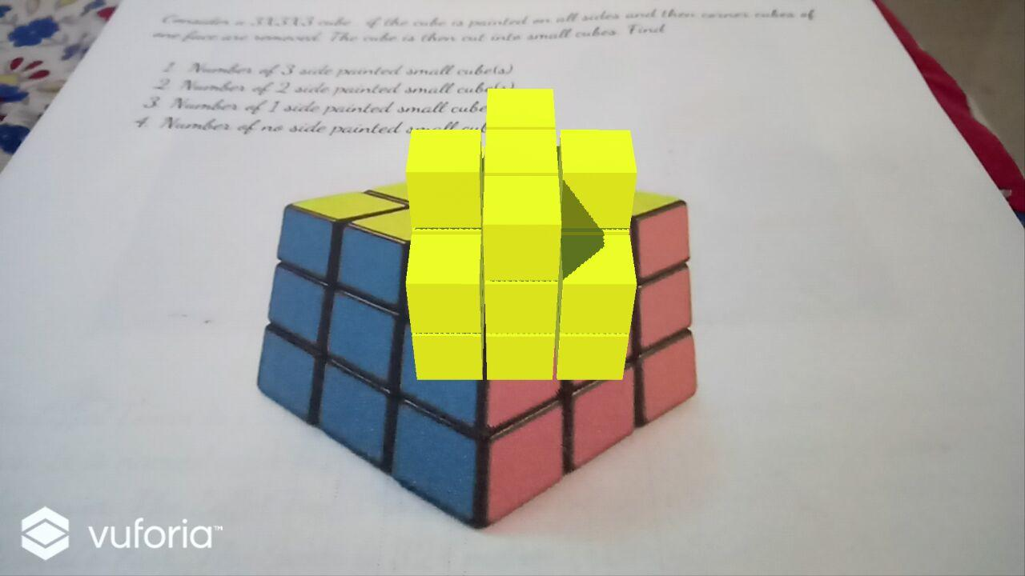

Fig 10: 3D visualization of painted cube problem

It is quite simple for a simple cube but becomes complicated when we cut small cubes from big one and then paint it. Students find it difficult to imagine how the cube would appear when small cubes are removed. By introducing AR in the painted cube problem, students will get an idea of how that cube might look like. Specific Problems will help the students to imagine the cube for other specific problems.

v. Virtual Jungle

Watching wildlife animals in their natural habitat is truly an amazing experience. Virtual Jungle is a VR based application which features wildlife and its various animals in the virtual world. The application has an inbuilt 3D environment which takes the user into a new world of virtual jungle. The User can roam in the environment and experience the realistic models of animal very closely.

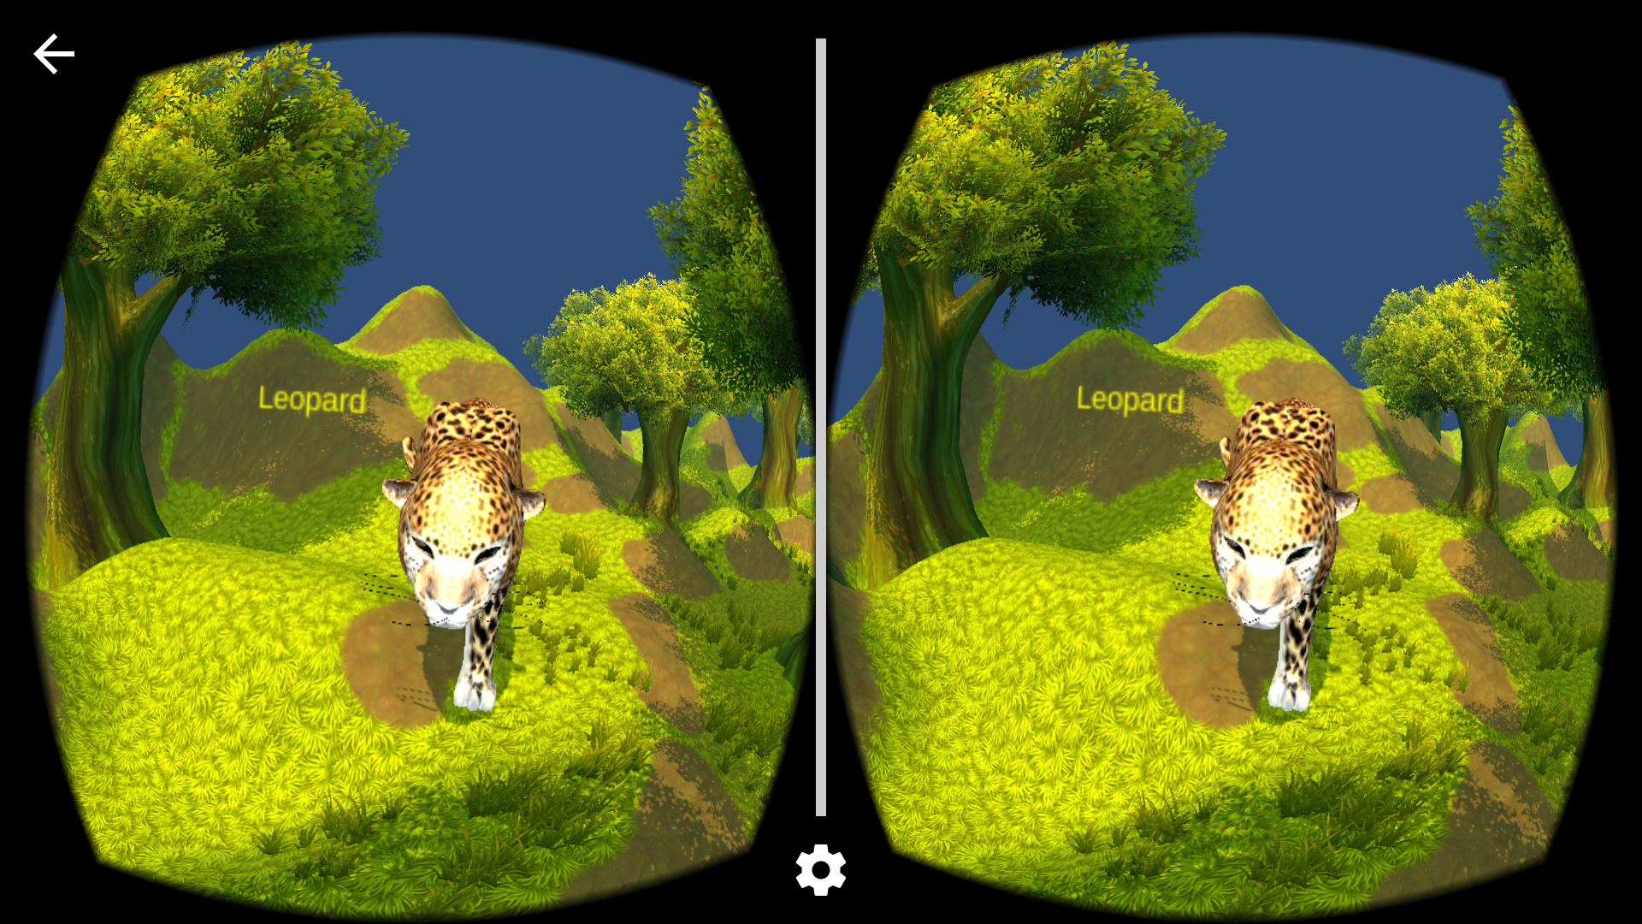

Fig 11 : Realistic 3d model of Cheetah in Virtual Jungle seen through a VR Headset

For experiencing the virtual jungle, we need a VR Headset(Google Cardboard) and a phone with a gyroscope and magnet. The gyroscope in the phone is essential because it maps the axis alignment of the real world into 3d axis of virtual world. The magnet in the phone is used to trigger the movement of the user in the virtual world, and it is controlled by a magnet present on the side of VR Headset which when you flick it upside down, triggers the movement and stops when flicked once again. Through Virtual Jungle, one can experience a whole jungle come alive in front of their eyes.

# Ⅵ. Conclusion

Augmented and Virtual reality have many applications in every field of sciences like Education, Medical, Military, Tourism, Architecture, Interior design and much more. They both are used to solve real-life problems in day to day life.  In this paper, we have discussed various ways in which augmented and virtual reality can be used in education to make it more creative, interactive and efficient. The various applications discussed in detail are visiting historical sites while sitting at home, storytelling, engineering drawing models for students and painted cube problems.

1. Acknowledgment

We are thankful to our college Vivekanand Education Society’s Institute of Technology for considering our research paper and extending help at all stages needed during our work of collecting information regarding the research paper.

It gives us immense pleasure to express our deep and sincere gratitude to Assistant Professor Mrs. Smita Jangale (Project Guide) for her kind help and valuable advice during the development of research paper and for her guidance and suggestions.

We wish to express our profound thanks to all those who helped us in gathering information about the project. Our families too have provided moral support and encouragement at several times.

1. References
2. Mehdi Mekni, Andre Lemieux(2014). Augmented Reality: Applications, Challenges and Future Trends. International Conference on Applied Computer and Applied Computational Science. pp 205-214. ISBN 978-960-474-368-1.
3. Nor Farhah Saidin1, Noor Dayana Abd Halim, Noraffandy Yahaya1 (June 25, 2015). A Review of Research on Augmented Reality in Education: Advantages and Applications. International Education Studies; Vol. 8, No. 13. ISSN 1913-9020 E-ISSN 1913-9039
4. Brian Boyles(2017). Virtual Reality and Augmented Reality in Education. CTE United States Military Academy.
5. Ronald Azuma, Yohan Baillot, Reinhold Behringer, Steven Feiner, Simon Julier, Blair MacIntyre (November 2001). Recent Advances in Augmented Reality. IEEE Computer Graphics and Applications. pp 34-47
6. Ronald T. Azuma(August 1997). A Survey of Augmented Reality. Teleoperators and Virtual. pp 355-385.
7. Antti Ajanki, Mark Billinghurst, Hannes Gamper, Melih Kandemir, Samuel Kaski, Markus Koskela, Mikko Kurimo, Teemu Ruokolainen, Timo Tossavainen(June 2011). An Augmented Reality Interface to Contextual Information. Virtual Reality. pp 161-173. ISSN: 1359-4338.
8. Peng Chen, Xiaolin Liu, Wei Cheng, Ronghuai Huang(September 2016). A review of using Augmented Reality in Education from 2011 to 2016. Innovations in Smart Learning. pp 13-18.
9. Stephanie Fleck, Martin Hachet, J.M. Christian Bastien(May 2015). Marker-based augmented reality: Instructional-design to improve children interactions with astronomical concepts. Interaction Design and Children(IDC) 2015. pp 21-28.
10. Jaewoon Lee, Yeonjin Kim, Myeong-Hyeon Heo, Dongho Kim, Byeong-Seok Shin(February 2015). Real-Time Projection-Based Augmented Reality System for Dynamic Objects in the Performing Arts. Advanced Symmetry Modelling and Services in Future IT Environments. pp 182-192
11. Alexandru Gherghina, Alexandru-Corneliu Olteanu, Nicolae Tapus(January 2013). A Marker-Based Augmented Reality System for Mobile Devices. 11th Roedunet International Conference (RoEduNet) 2013.
12. Yann Argotti, Larry Davis, Valerie Outters, Jannick P. Rolland(October 2001). Dynamic Superimposition of Synthetic Objects on Rigid and Simple-Deformable Real Objects.IEEE and ACM International Symposium on Augmented Reality (ISAR'01).
13. Fig 2. https://www.digit.in/technology-guides/fasttrack-to-augmented-reality/different-types-of-augmented-reality.html

1.